**DAILY ONLINE ACTIVITIES SUMMARY**

|  |  |  |  |  |  |  |  |  |
| --- | --- | --- | --- | --- | --- | --- | --- | --- |
| **Date:** | **23/06/2020** | | | | | **Name:** | **V ANJANA PAI** | |
| **Sem & Sec** | **IV sem & B section** | | | | | **USN:** | **4AL18CS094** | |
| **Online Test Summary** | | | | | | | | |
| **Subject** | | **-** | | | | | | |
| **Max. Marks** | | **30** | | **Score** | | | **-** | |
| **Certification Course Summary** | | | | | | | | |
| **Course** | **Blockchain Basics** | | | | | | | |
| **Certificate Provider** | | | **Great learning academy** | | **Duration** | | | **2.5hours** |
| **Coding Challenges** | | | | | | | | |
| **Problem Statement1:** Write a C Program to Sort a stack using a temporary stack.  **Problem Statement2:** Python Program to Split the array and add the first part to the end There is a given an array and split it from a specified position, and move the first part of array add to the end. | | | | | | | | |
| **Status: Executed** | | | | | | | | |
| **Uploaded the report in GitHub** | | | | | **YES** | | | |
| **If yes Repository name** | | | | | **lockdown-coding** | | | |
| **Uploaded the report in slack** | | | | | **YES** | | | |

Online Test Summary: No internals conducted today.

Online Certification Course Summary: In today’s session I have learnt about Database Vs Blockchain and also their advantages. And also learnt about Role of Intermediaries with examples.

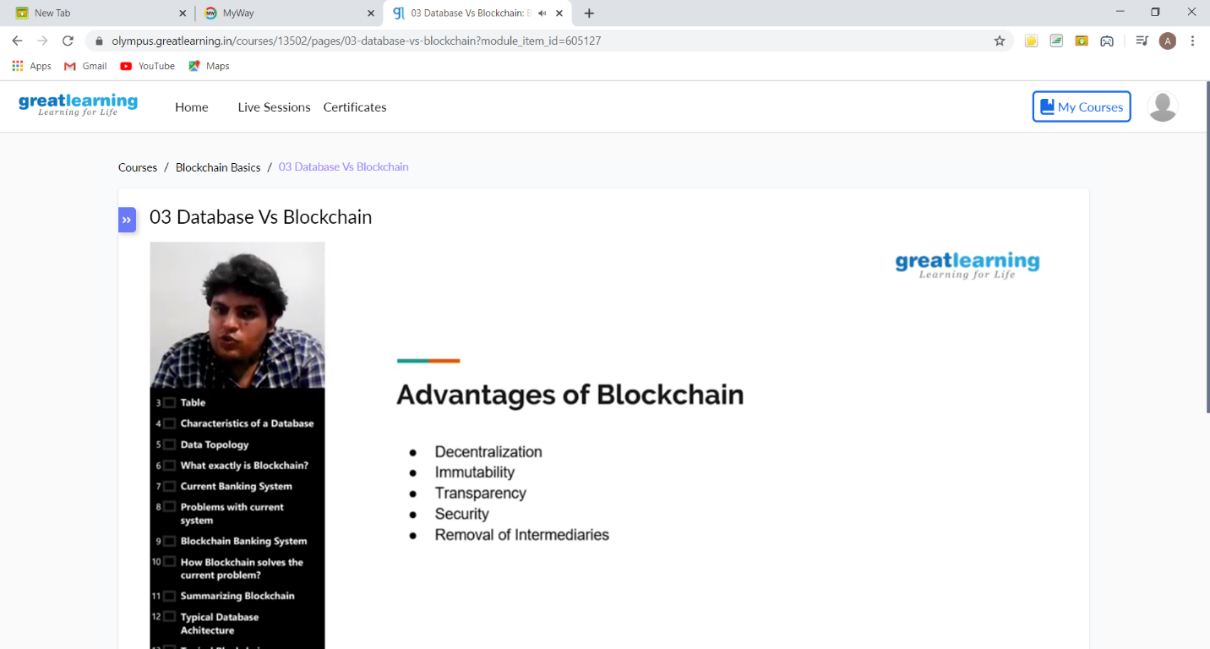

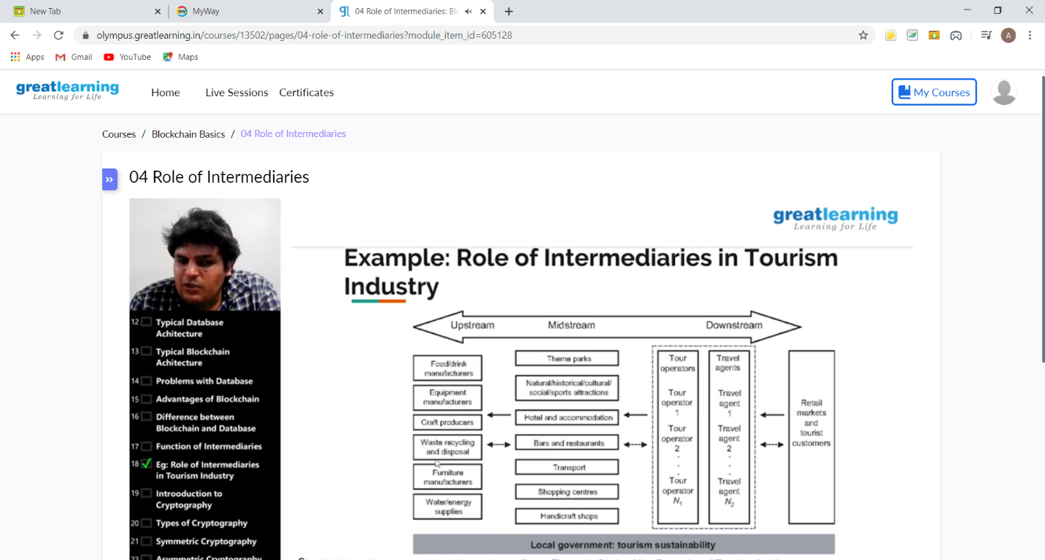

This is the snap shot of today’s session.

Online Coding Summary: **Today I had received one program from prof. Venkatesh CSE Dept. and prof. Vasudev CSE Dept. The program is mentioned above in the coding challenges(pg.01). I have also uploaded it to my GitHub repository.**

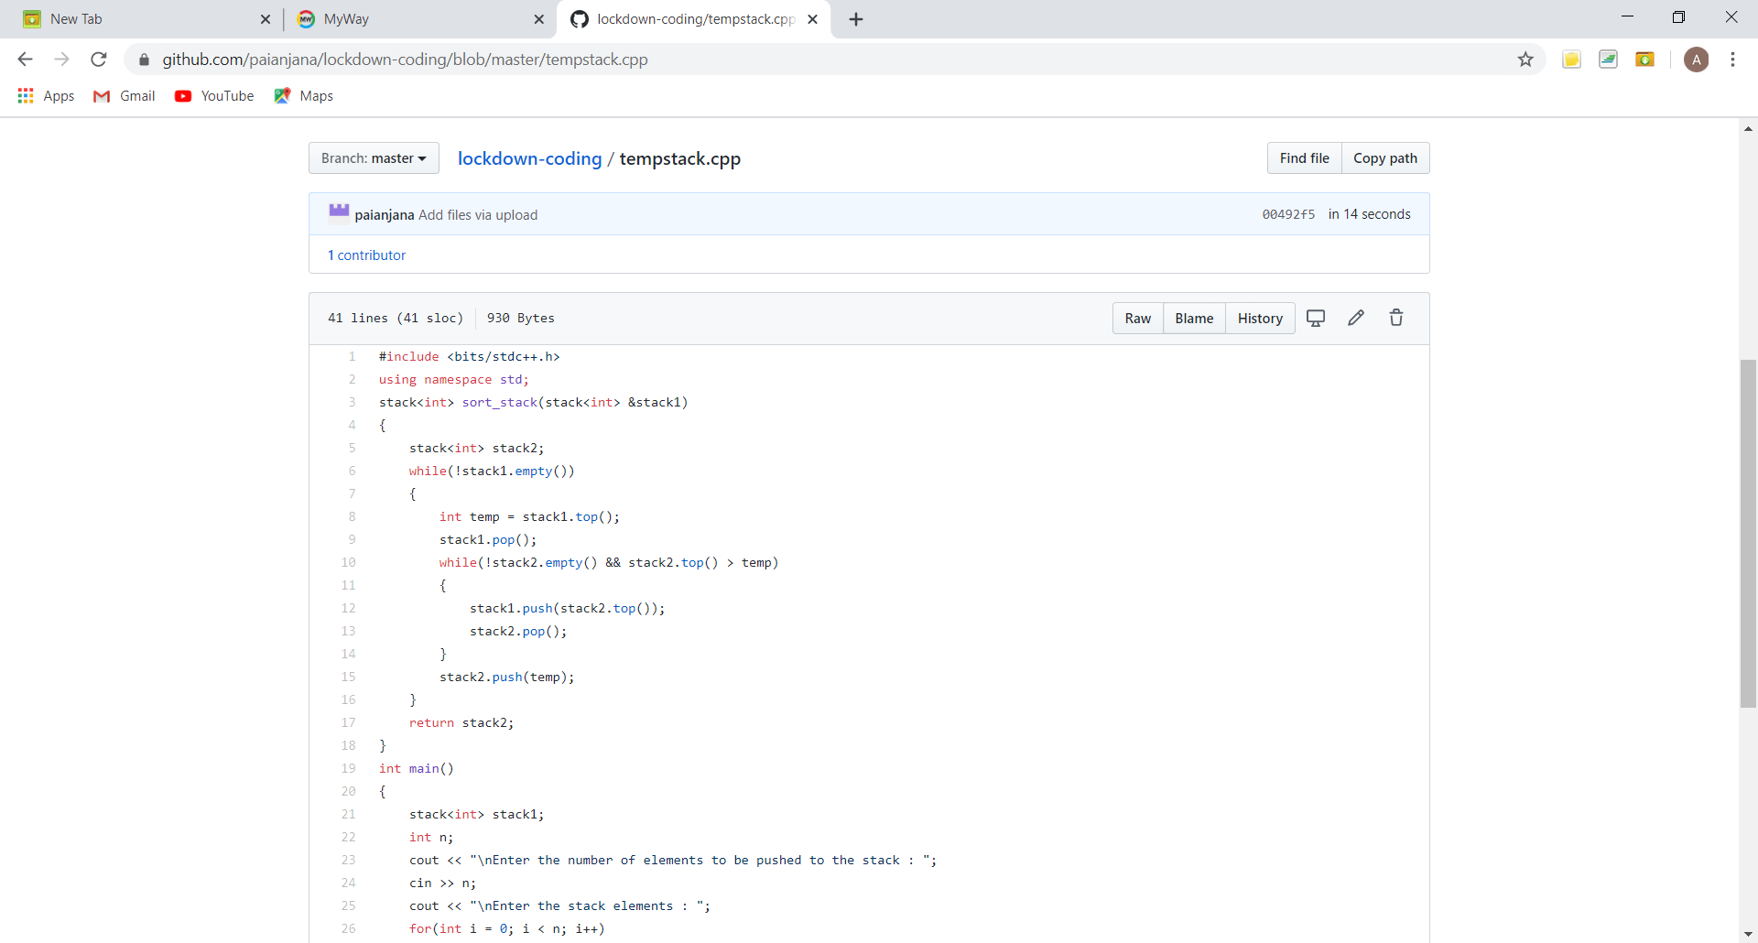

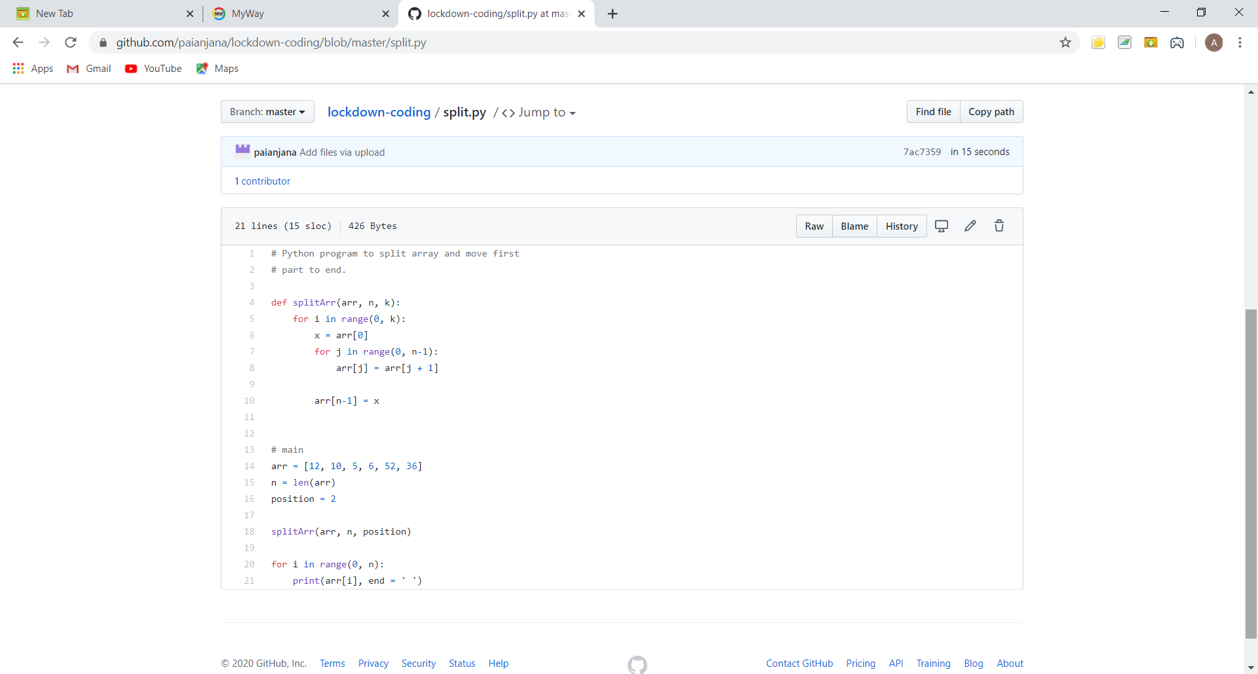

**This is the snap shot of my GitHub repository** where I have uploaded the code. File name tempstack.cpp and split.py

Webinar: Today I had attended the webinar organized by CSE Department AIET. The webinar was on Internet of Things-Opportunities and Challenges done by Prof. Sushant M CSE Dept.